**Data Analyst in Power BI Data-Camp 2025**

**Section 12: Exploratory Data Analysis in Power BI**

**Initial Exploratory Data Analysis in Power BI**

1. **Initial Exploratory Data Analysis in Power BIA screenshot of a computer

   AI-generated content may be incorrect.**

**Exercise 1.1**

**Exercise 1.2**

**In a right-skewed distribution,** the mean is typically greater than the median. This is because the extreme values in the longer tail (the right side)pull the mean towards them, making it higher than the median, which is less affected by outliers.

**In a left-skewed distribution,** the mean is typically less than the median. The extreme low values in the longer tail (the left side) pull the mean towards them, making it lower than the median.

**For a symmetric distribution,** the mean and median are approximately equal.

**Exercise 1.3**

[**ISBLANK function (DAX) - DAX | Microsoft Learn**](https://learn.microsoft.com/en-us/dax/isblank-function-dax)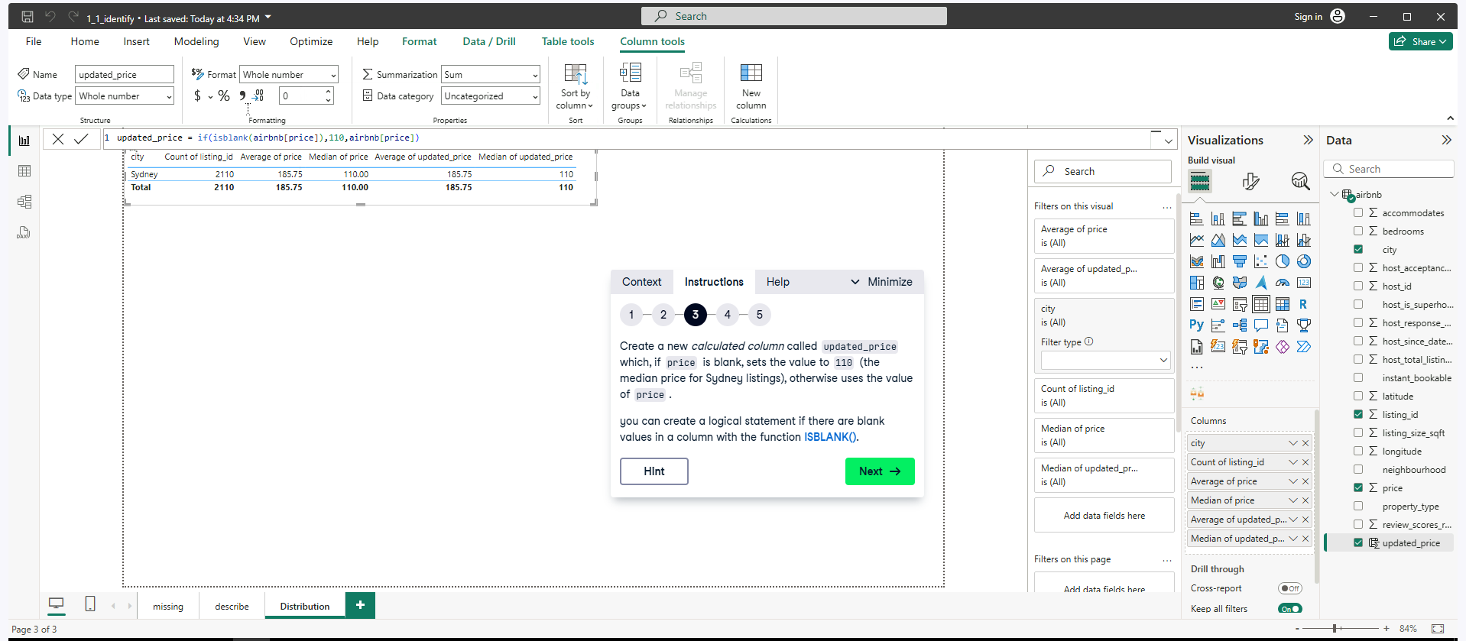

1. **Distributions and Outliers**

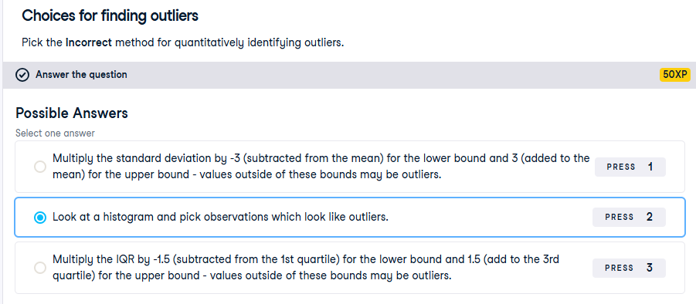

**Exercise 2.1**

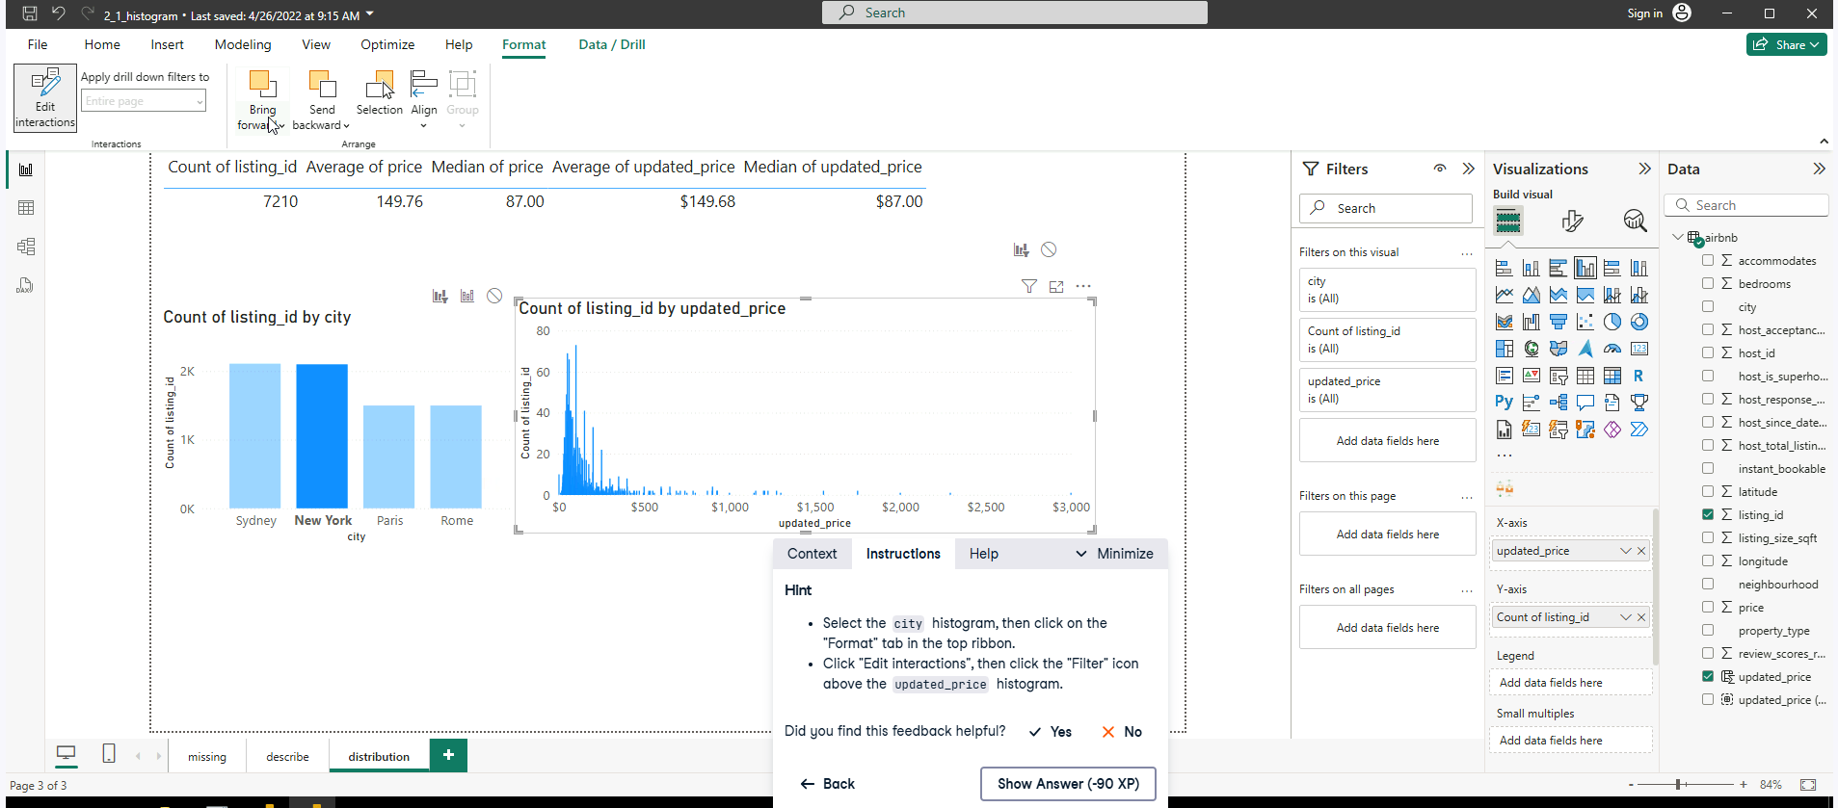

**Exercise 2.2**

[**https://learn.microsoft.com/en-us/dax/percentile-inc-function-dax**](https://learn.microsoft.com/en-us/dax/percentile-inc-function-dax)

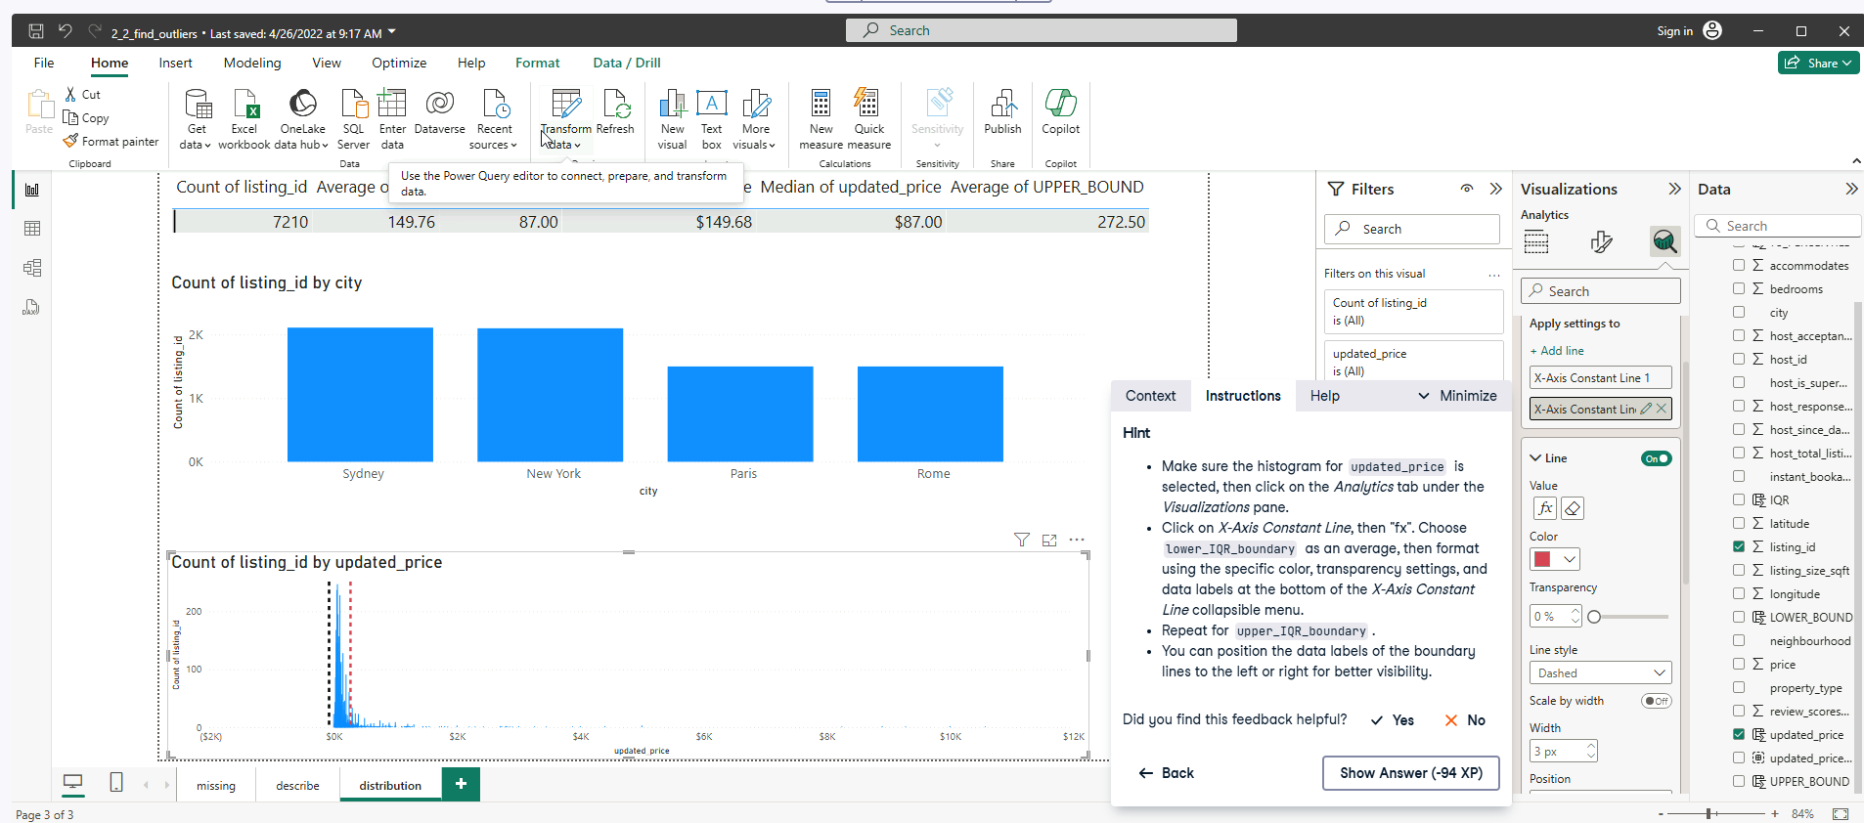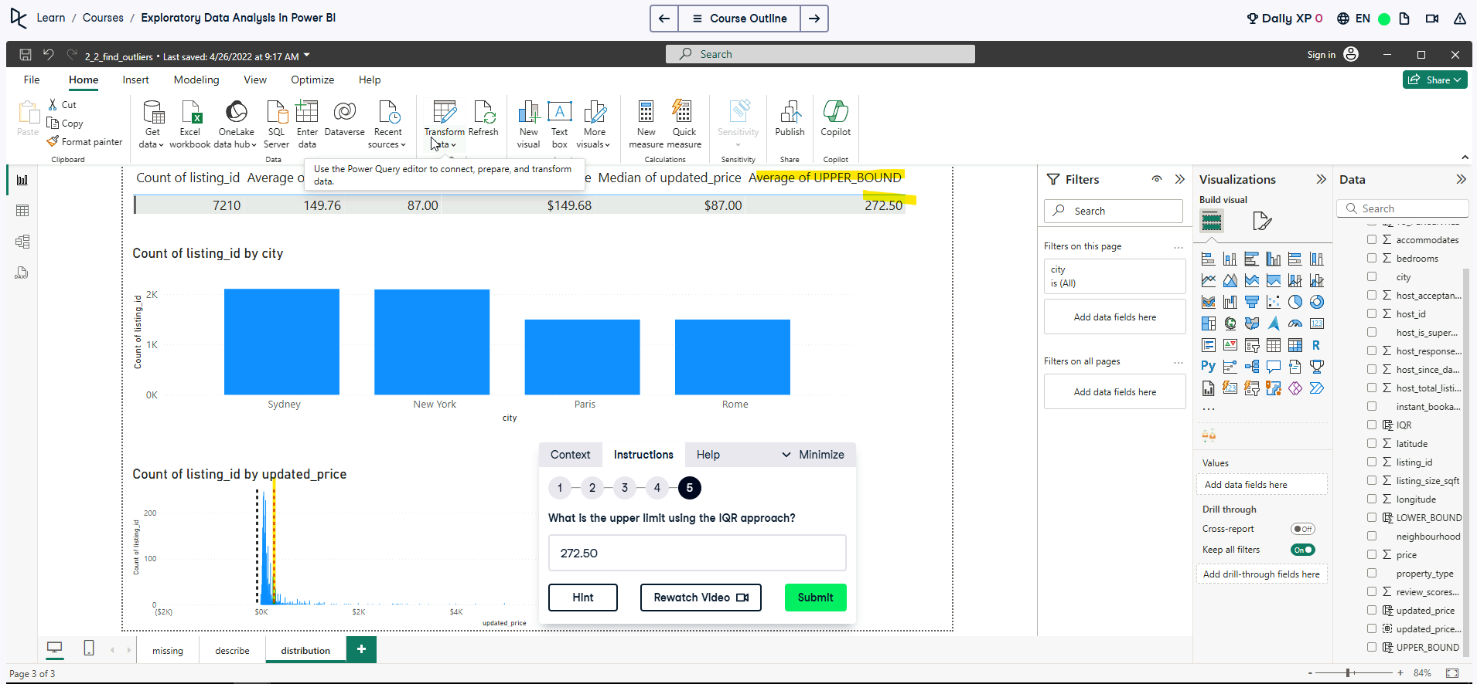

**Note:** if you can not observe the data-point for the upper bound. Use Average on the upper bound column into the table, distribution page.

**

**Note:** After following the modified price DAX column see below. Replace the updated price column in the histogram and remove the two-axis from the previous exercise.

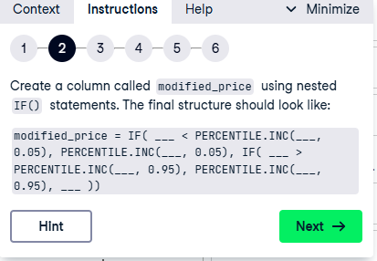 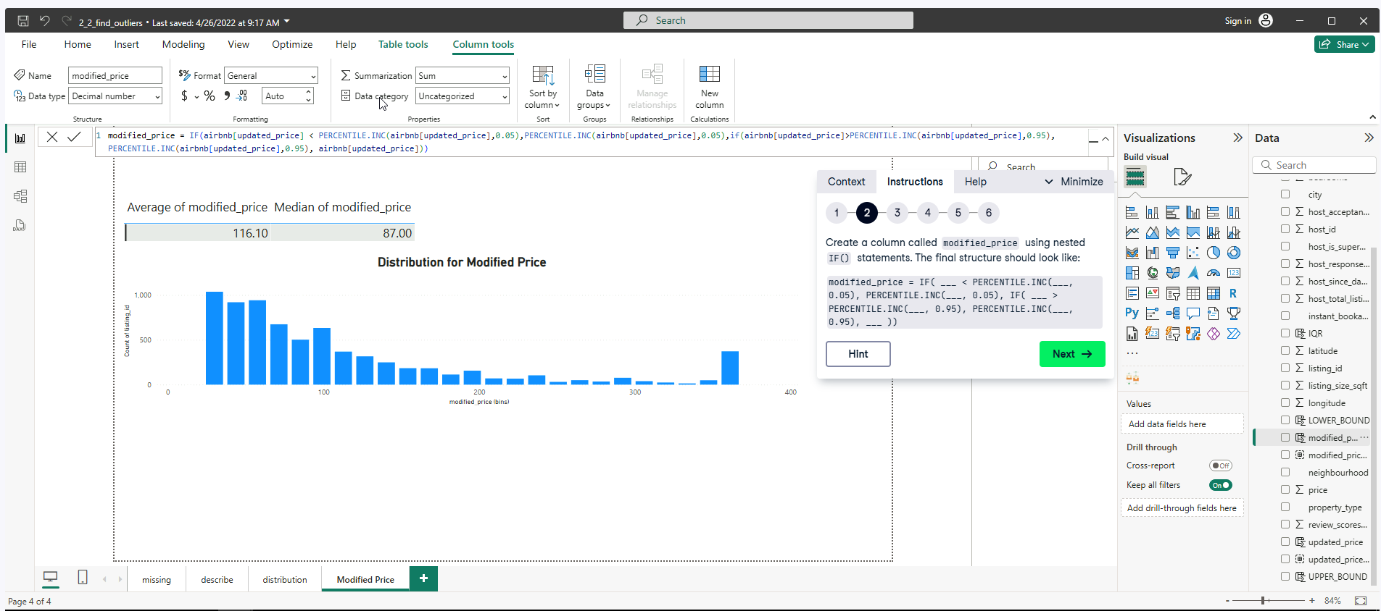

**EDA with Categorical Variables**

**Exercise 3.1**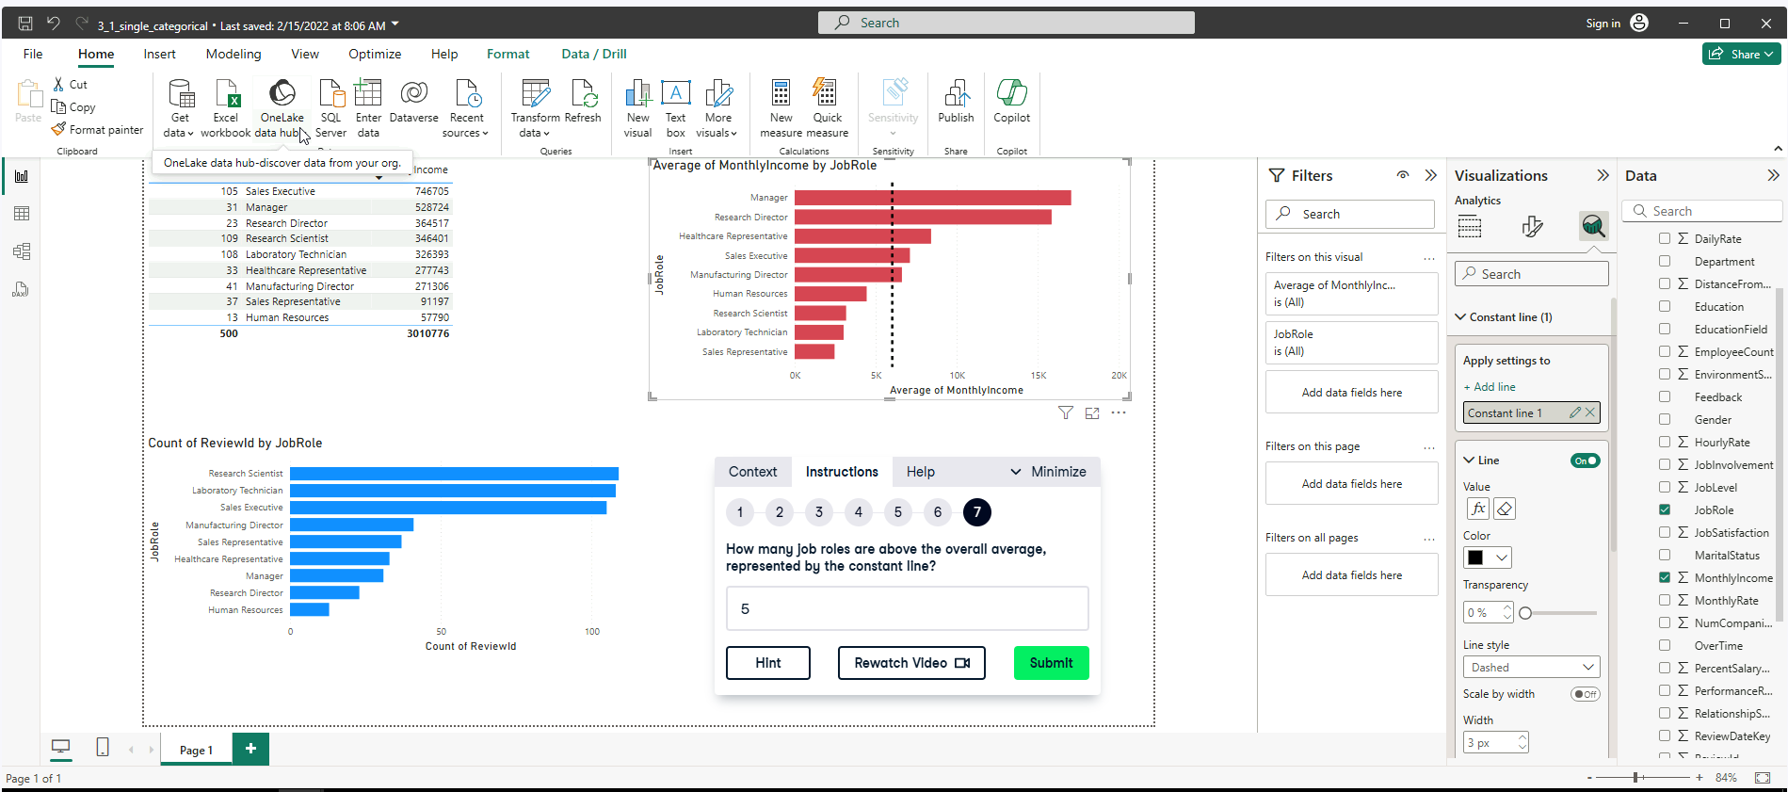

**Exercise 3.2**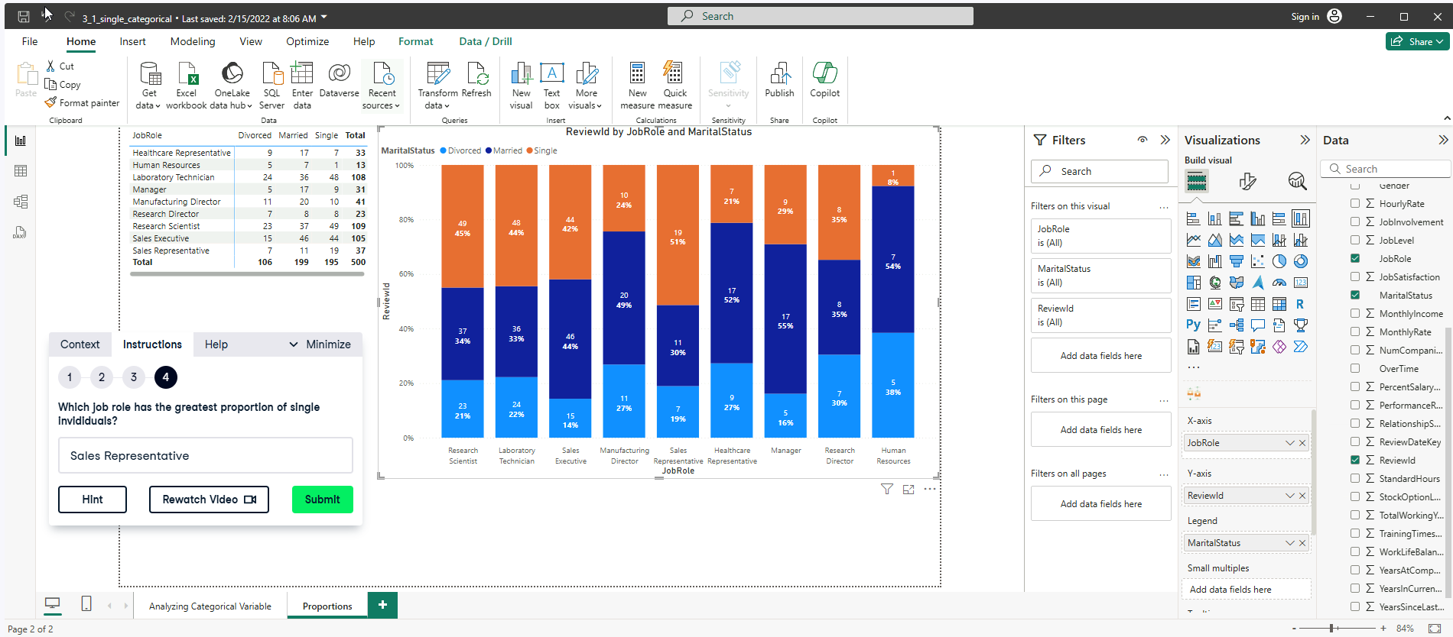

**Exercise 3.3**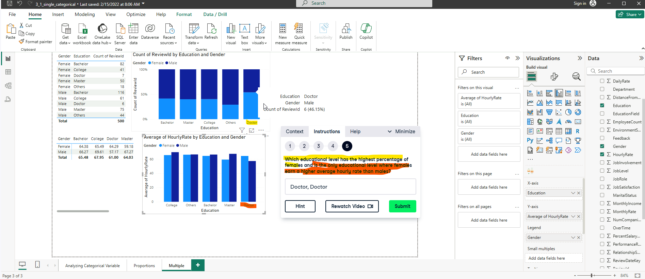

**Exercise 3.4**

<https://learn.microsoft.com/en-us/dax/switch-function-dax>

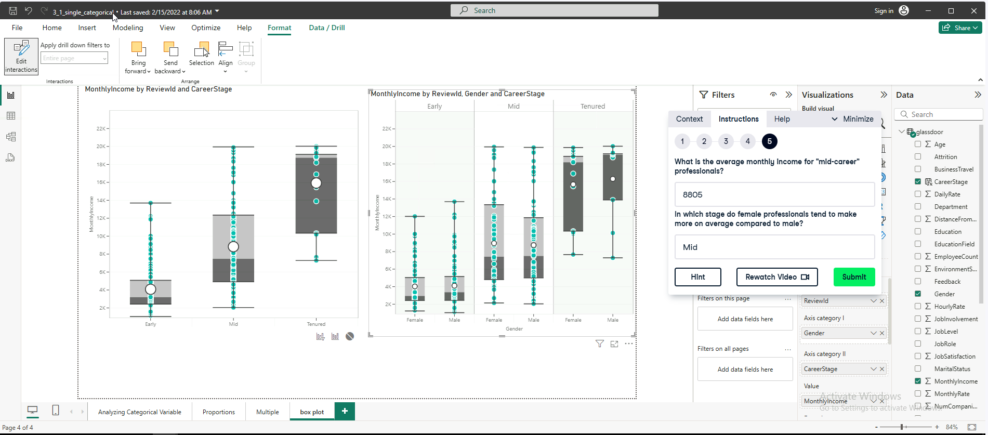

**Relationships between Continuous Variables** 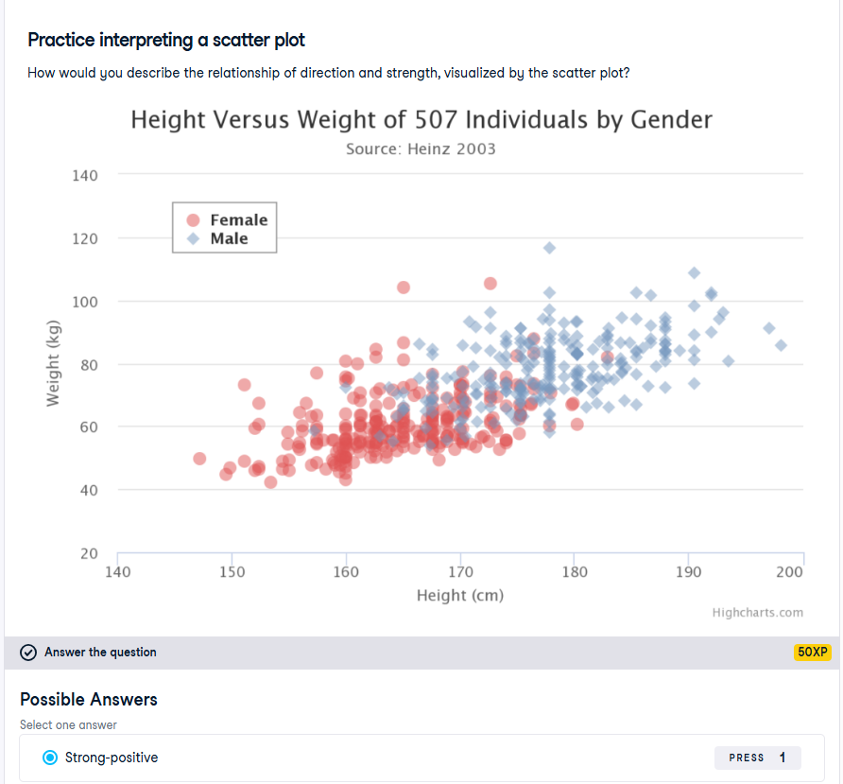

**Exercise 4.1**

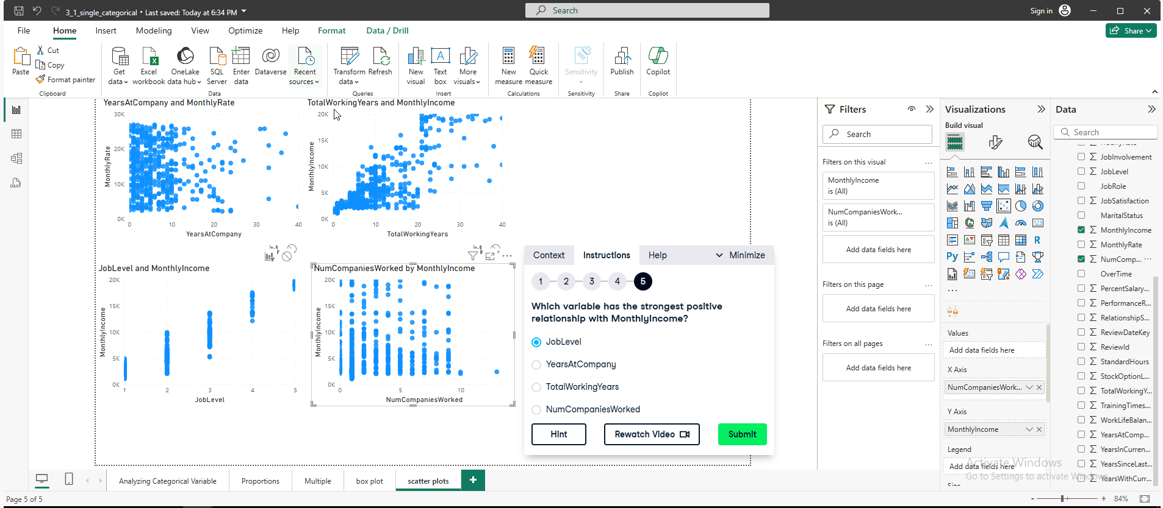

**Exercise 4.2**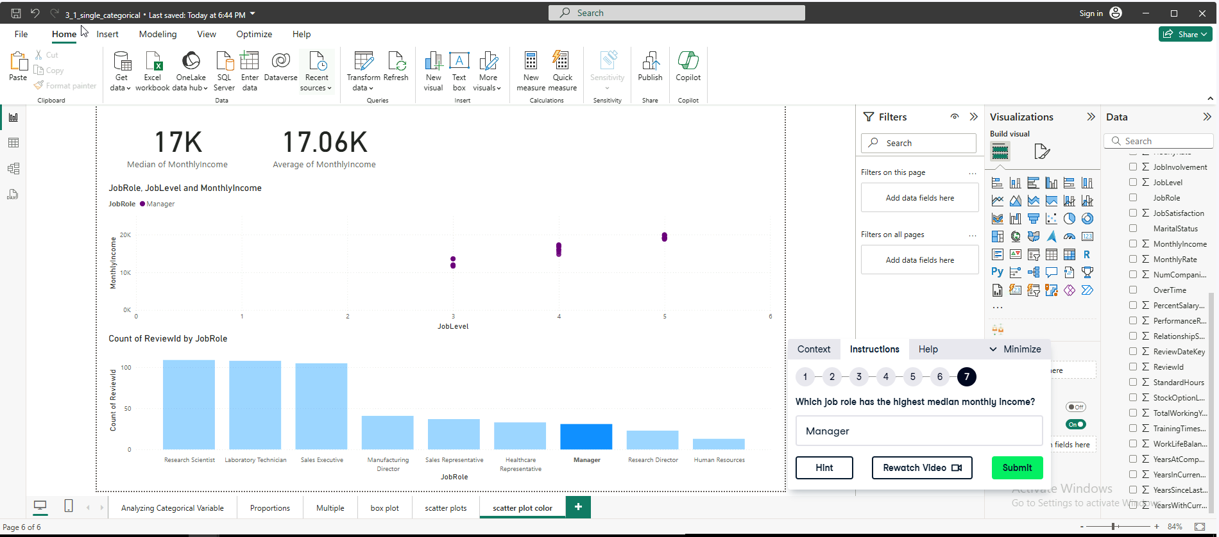

**Exercise 4.3**

